Bike Company Analysis Report

# Business problem:

As the world is moving towards more eco-friendly transportation, the bike industry will play a pivotal role by providing individuals with a diverse range of products that are convenient and tailored to their unique needs and preferences. However, the bike industry has seen various challenges in recent times and its ability to overcome these challenges and capitalize on opportunities will determine its future. A few of the challenges that the bike companies face includes addressing changing customer behavior and economic factors, optimizing inventory, and increasing competition from online retailers. This analysis will aim to leverage data driven insights to address the challenges faced by a bike company called City Cycles and help them open new avenues to stay ahead and drive business growth.

The dataset that will be utilized for our analysis is obtained from Kaggle, which provides valuable information about the sales performance, staff performance, product inventory and customer demographics. With this rich dataset, this report aims to identify key trends and insights to improve the company’s operation and decision making and provide recommendations to drive sustainable growth.

# Assumption:

There are two assumptions that are made for this analysis. One assumption is that the dataset accurately reflects the real-world operations, this includes the sales transaction and inventory management. Another assumption is that information in dataset, which dates back to 2016 is still relevant and can be used to provide meaningful insights.

# Hypothesis:

One hypothesis for my analysis is that customer demographic such as location and age have an impact on the overall sales and the type of bike purchased. The second hypothesis is that maintaining an optimal inventory turnover can increase profitability.

# Analysis:

Question 1: How many customers did the business have per year?

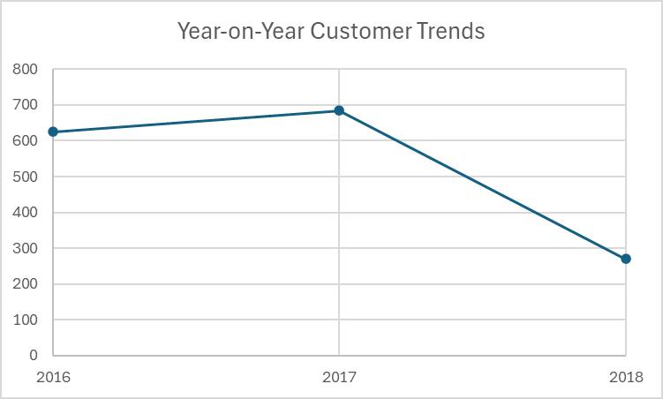

The graph illustrates the trend of annual unique customers between 2016 to 2018. There is noticeable decline in the total number of customers in the year 2018 and the reason behind it needs to be investigated. T here could be several factors causing this decline such as change in customer behavior, shift in market dynamics or a result of poor customer satisfaction. Based on this finding, it is recommended that the business looks into its customer retention strategy and improve marketing or address any other issues that might have caused this decline to increase the customer numbers.

Question 2: What is the average order value over the years?

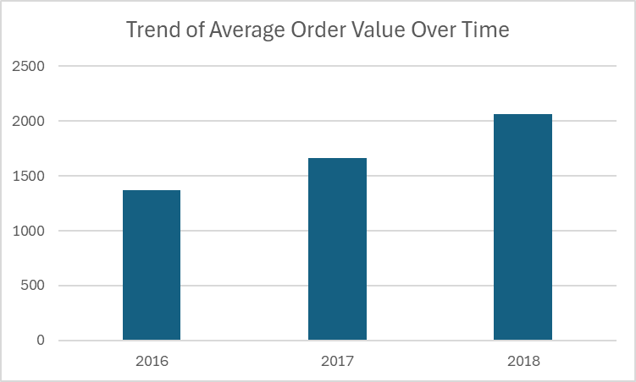

The visualization demonstrates a consistent growth in the average order value over the three-year period. This suggests that the customer may be purchasing more expensive products or more products per order. Overall, the strategies put in place to encourage customers to spend more have worked despite a decline in customer numbers in 2018.

Question 3: What is the number of customers per category?

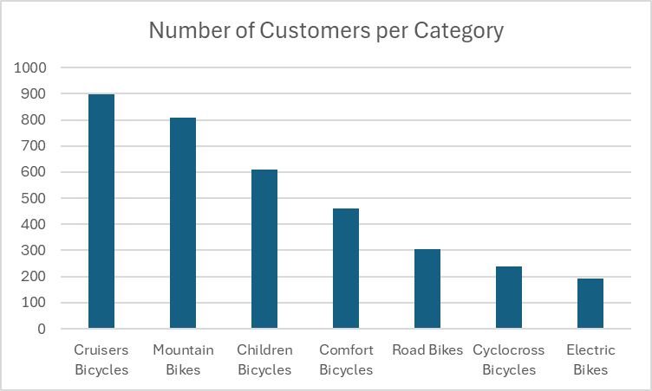

This bar graph shows that the Cruisers Bicycles and the Mountain Bikes are the topmost selling categories indicating a high demand for these types of bikes from the customers. There are also high demands for Children Bicycles and Comfort Bicycles showcasing the diverse preferences of City Cycles' customers. On the other hand, the Cyclocross Bicycles and Electric Bikes have lower demands, and this could be due to the fact that these categories are catering to a niche market or haven’t yet gained popularity among customers. A recommendation would be to leverage on the popularity of the top-selling categories but also come up with strategies to increase the appeal for Cyclocross Bicycles and Electric Bikes through promotional campaign such as limited time discounts or bundle deals.

Question 4: What is the number of customers per category?

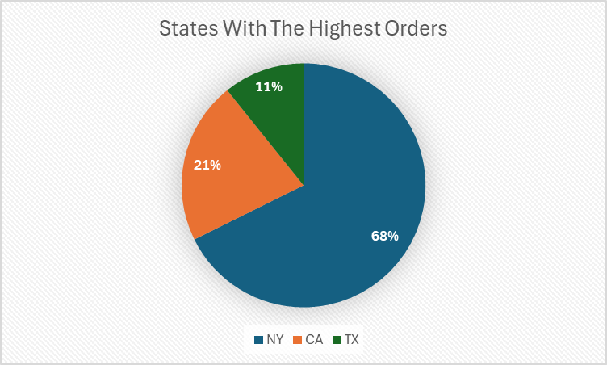

This pie chart shows the geographical distribution of City Cycles' customers. Based on the above visualization, it is evident that a large portion of the orders are coming from New York (NY). This insight can be leveraged to allocate more resources and marketing effort for the customers based in New York. This includes optimizing the inventory, so that it meets the high customer demand. Furthermore, the company could look for opportunities to solidify their presence in California and Texas to capture a larger market. The company can do this by conducting a target market campaign tailored to the California and Texas customers, this would help build brand awareness and drive sales growth. It is also important to do market research for the two states based on cycling infrastructure, population density, and local biking culture. Based on this research, it is recommended that the company should do an evaluation to determine whether they should explore markets in other states with a more thriving cycling community.

Question 5: what is the staff distribution across states?

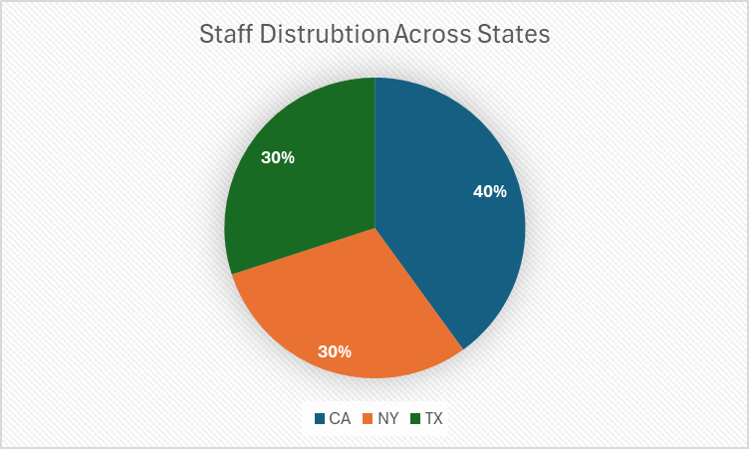

New York has fewer staff than California, even though it accounts for a large portion of the orders (68%) compared to California that accounts for only 21% of the total orders. This indicates that there might be a higher workload on the staff in New York compared to California and Texas. To optimize the operations and ensure workload balance, consider adjusting the staffing level by hiring additional staff at the New York branch and potentially firing or maintaining the staffing levels at the other two branches. This approach will help better manage the higher order volume in New York and improve customer satisfaction.

Question 6: What are the top and bottom 10 selling products by Revenue?

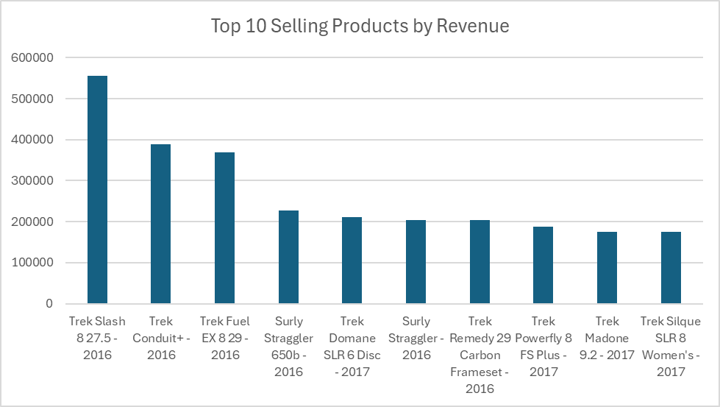

The top selling products predominately belong to big brands such as Trek and Surly showcasing the importance of brand’s trust and loyalty of the customers in an industry like bikes. A recommendation would be to ensure an adequate amount of stock available for these top-selling products to meet the needs of the customers effectively. Also, another recommendation would be to evaluate the types of brands in the lower performing categories and consider introducing branded products in those categories if they are not already present.

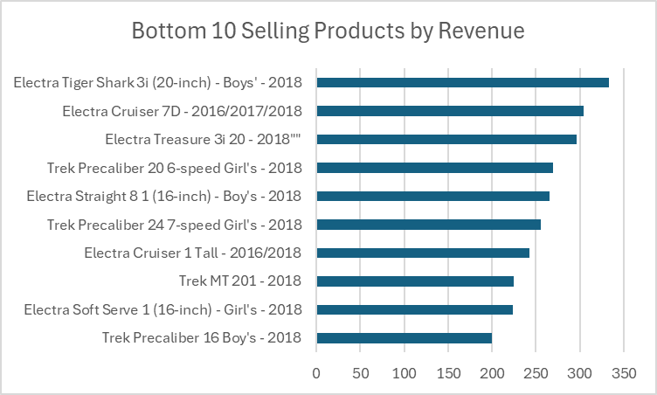

There seems to be prevalence of Electric Bikes in the bottom selling product indicating a less demand for Electric Bikes compared to the traditional bikes. Based on this, a recommendation would be to get customer feedback on top and bottom-selling products and review market trends to decide whether to discontinue a product or not.

Question 7: What are the top 10 products in terms of turnover rate, and what are the bottom 10 products?

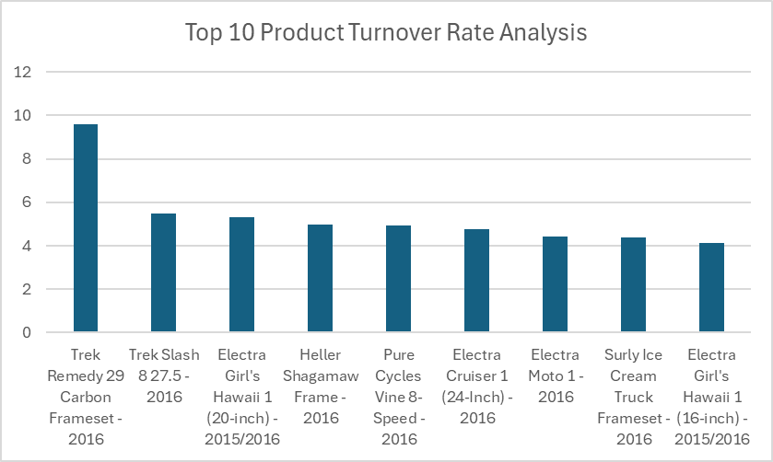

An interesting observation can be made from the above visualization, although Electric Bikes is the least popular category, there are some Electric Bike products that have a higher turnover rate. This indicates that certain products are high in demand and sell relatively quickly. These products can be highly valuable and optimizing their inventory levels to meet the customer demands can help improve overall revenue and maximize profit.

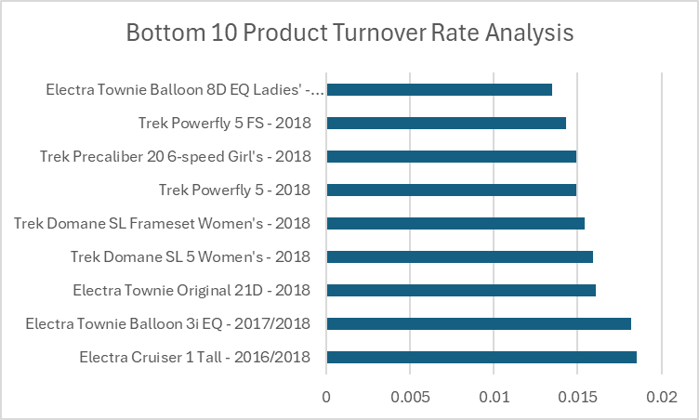

These products above have a lower turnover rate, and these products could be affecting the company due to the incurred holding cost associated with storing the inventory. It can be seen that most of the products cater to a niche market and may also be less popular among the customers. A recommendation would be to offer discounts or incentives to clear out the slow-moving inventory. Another recommendation would be to review the company’s inventory management policies to ensure that these products are not overstocked.

# Conclusion:

In conclusion, the analysis of the bike sales data revealed many important insights that can help the company. A few notably observations were that the company had a significant decrease in customers during 2018, which needs to be reviewed. Cruisers Bicycles and Mountain Bikes are the top choices for the customers compared to more niche categories such as Electric Bikes and Cyclocross Bicycles. However, Electric Bikes have a high turnover rate, indicating that with increased promotions and marketing efforts, there could be a potential growth in sales. Another interesting insight gained from the analysis was that New York accounts for 68% of the sales but due to an imbalance in staffing levels, there could be a constraint in fulfilling orders on time. Moving forward, the company should look at addressing the staffing issues and strategically managing their inventory to ensure customer satisfaction. By leveraging these insights and recommendations, the company can better align its offering with the customer preferences and maintain a competitive edge in the market.